Tools to start with
Jerry's Basic Jewelry Bench-work

Livingston Jewelers
livingstonjewelers.com

Here is my list of what to start with for tools. This document is Copyright Gerald A. Livings. All opinions and suggestions are mine. No warranty or copyright infringements are meant.

Benches
The first thing you want to look for is a sturdy bench that is stable when you pound on it. You can start by making a simple wood tray like the one below, make a small bench of your own or purchase one from a supplier. If you search on the Internet you can find many examples of what people have used to make a jewelry bench. Below you will see a simple bench that can fit on a table or a sturdy chair. I have also included a picture of the first bench that I made over 20 years ago when I was just starting out. This bench is still in use as my soldering bench.

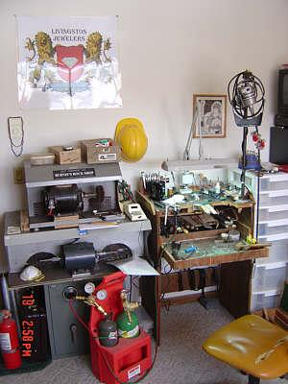
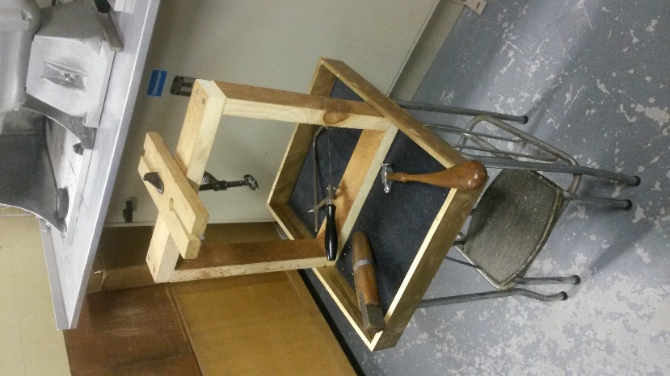

The rest of the items are important but no one tool is more or less important than any other. As you can afford them and need them, build your tool set. I am listing them alphabetically below.

Bench pins
You will need a bench pin to work from. You will want a pin that is above a tray so any filings and parts have a place to collect. You can purchase a pin with an anvil attached, a pin with a simple clamp, or you can make one from a sturdy piece of wood and a C-clamp. The bench pin is where you will do most of your work and will need to be replaced once in a while. You can also have some that are shaped to perform particular tasks.
From left to right:
- A simple pin attached to your bench with a C-clamp
- A bench pin in a commercially available bench pin holder
- A bench pin/ anvil clamp
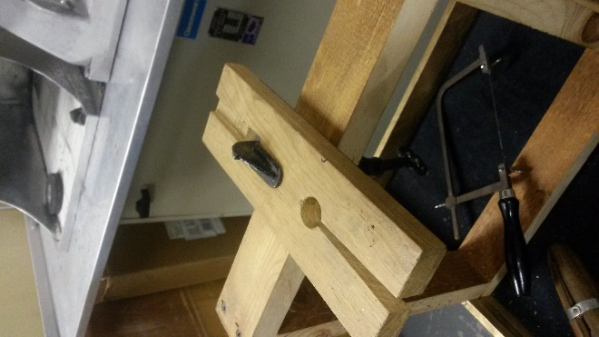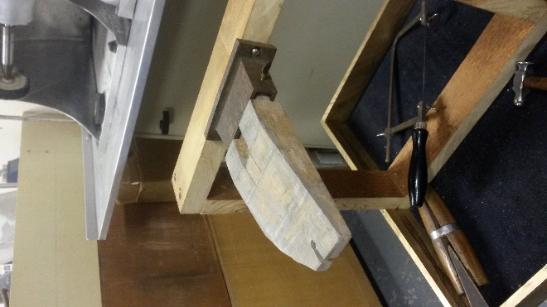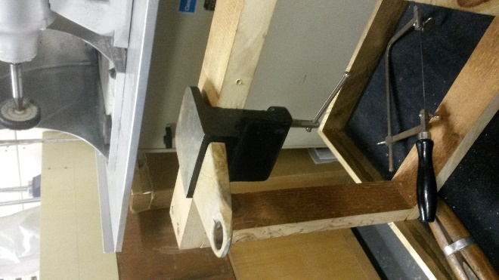

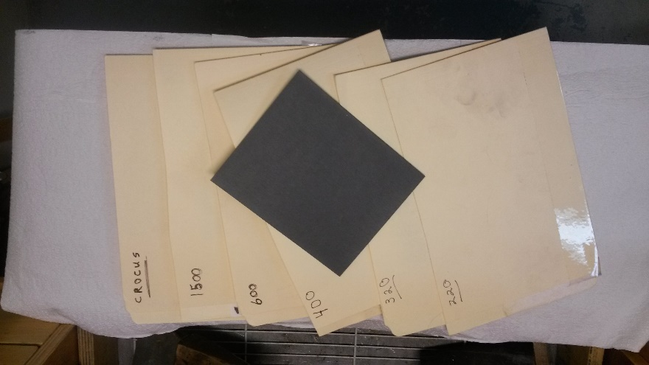
Abrasives
The abrasive you will use the most is sandpaper. Sandpaper comes in many grits and types. You will want to keep on hand the following grits: 220, 320, 400, 600, 1200, 1500 and also crocus paper. I keep mine cut into ¼ sheets and file them in sleeves. Take some file folders and cut in half, tape up one side and keep your sandpaper in these.

Adhesives
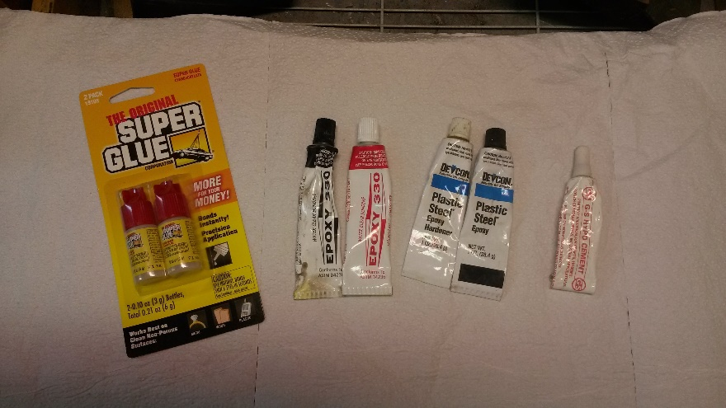
You will need to have some adhesives on hand for many projects. Some of the ones I use are super glue. The Epoxy 330 comes in handy for many things. The plastic steel comes in handy for attaching wood to metal such as file handles and the G-S Hypo Cement is a slightly flexible cement designed for attaching watch crystals to watch cases. It is great for gluing the ends of silk when restringing beads as well as attaching pearls to post settings. You will find many other uses as well.

Bench blocks
A bench block provides a very hard, flat surface. It is normally used to flatten metal and for riveting. The side of a dapping block works well also for this. You can buy some and you can visit your local junk yard and look for scraps of iron that will work.
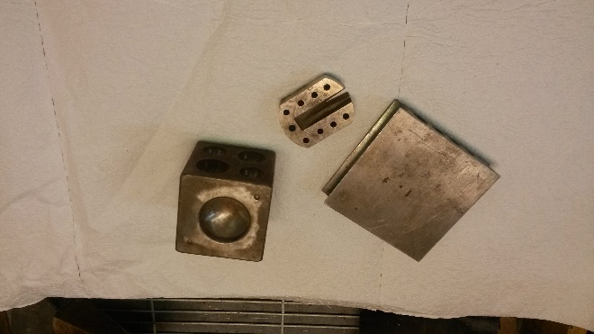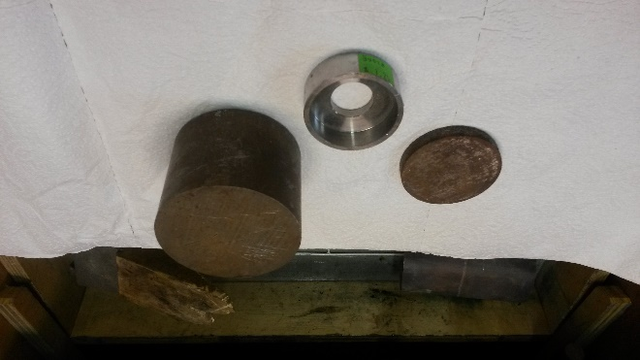

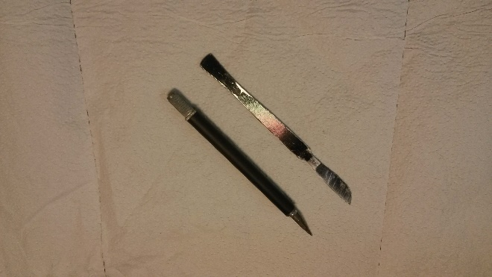
Bench knife
You can purchase a bench knife but I find that an old scalpel works just as well. An exacto-knife is also very handy to have as you can switch the blades to fit the task at hand.

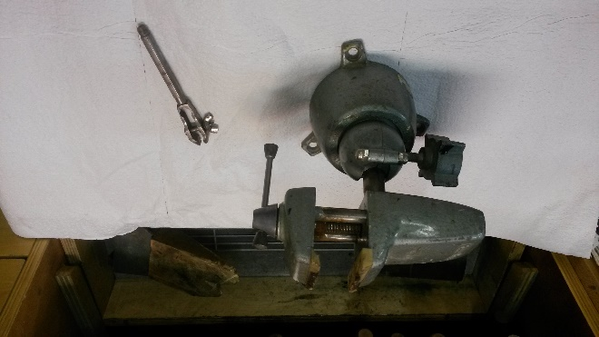
Bench vise
Pick up a small hand vise as it comes in handy more often than you think! The larger ‘Pan-A-Vise’ is not needed when you start out but it is nice to have one if you can afford to have one.

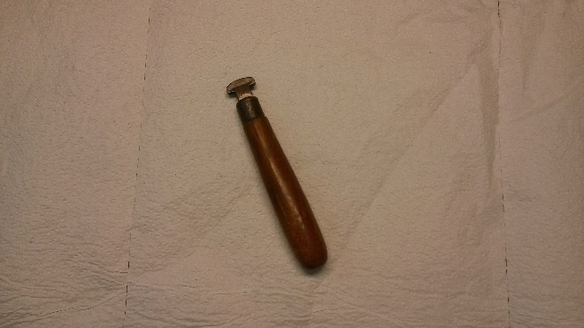
Bezel roller
A bezel roller is used to ‘roll’ the edges of bezels around stones smoothly and uniformly. It looks a bit like a short, fat letter ‘T’. Make sure that you use a fine grit of sandpaper on the face before using it as you want it to have a bit of ‘grab’ on the bezel as you work them down to the stone.

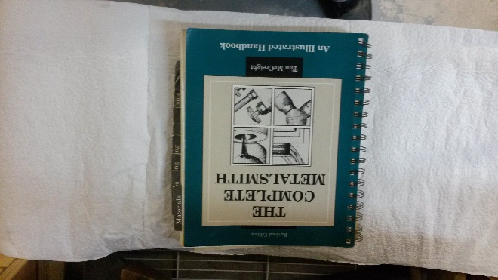
Books
If there is one book to get I would suggest getting “The Complete Metalsmith” by Tim McCreight. It is the one I started with and in my humble opinion, still one of the best.

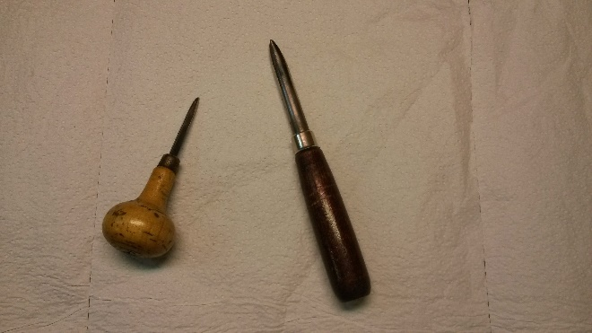
Burnishers
A polished bar of steel or agate that is used for burnishing metal. They come in many shapes and sizes and you will find many uses for them. You can make your own out of any steel scraps you have laying around.

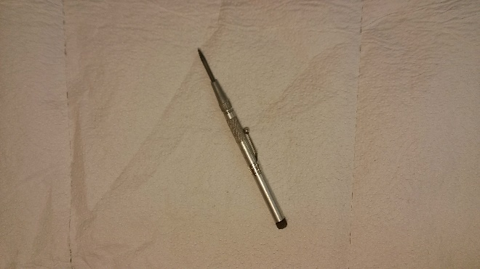
Center punch
Used to mark metal with a small depression. Usually used to mark where you will be drilling a hole as this keeps the drill bit from wandering.

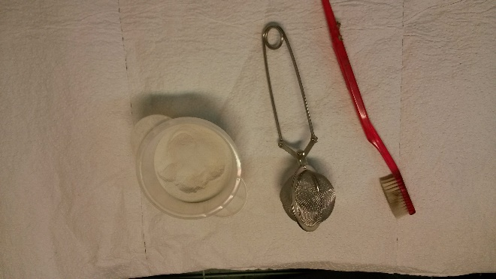
Cleaning
There are many items used to clean your work (and yourself) in the shop. The basic items you will use all of the time will be an old soft toothbrush. You should change your toothbrush every month so you should always have a steady supply to use in your shop! A tea strainer is great for use as a small parts basket and you will want to pick up some ground pumice stone. For most cleaning a mild dish detergent works well.

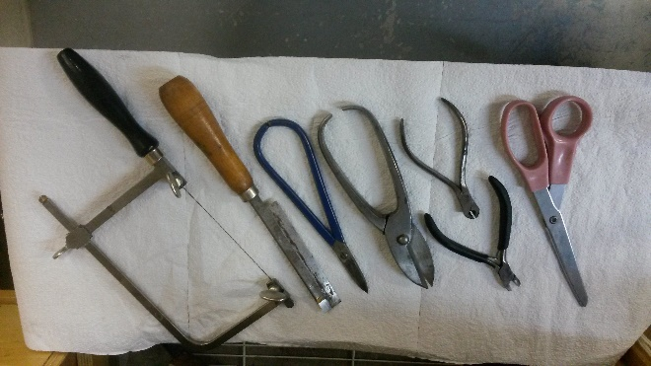
Cutting tools
You will many different cutting tools in your shop. From left to right they include basic paper scissors, metal snips, flush metal cutting snips, large hand shears, small hand shears, wax saw. The item on the far right is what you will use the most, your jewelers saw.

Drawing and Measuring
Accurate measurements are very important for beautiful jewelry. The basic tools you will want are the two items on the left in the first image below, a small ruler with inch and mm markings as well as a small brass caliper. You may want to also pick up a fancier caliper and you may eventually pick up a variety of gem measurement tools as well. You should pick up a selection of templates with different shapes to help you design items as well as keep some white laser printer paper cut into 3 by 3 inch squares. A good selection of pencils with different hardness of leads will come in very handy also.
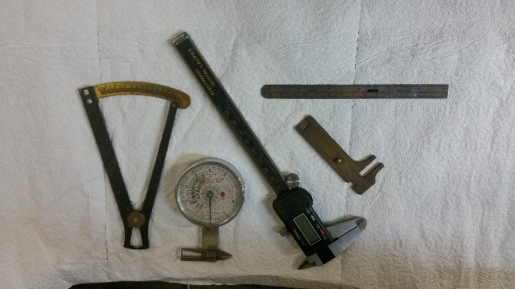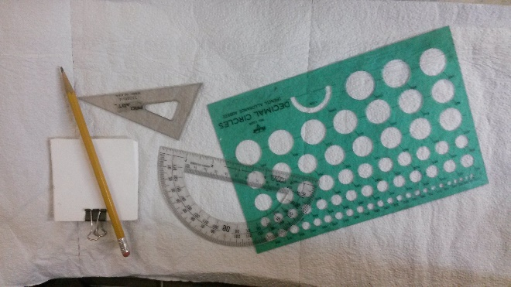

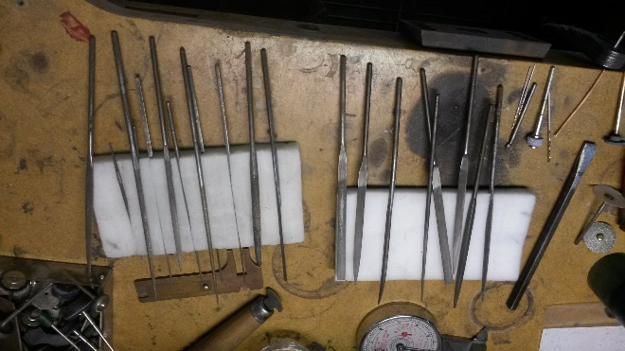
Files
If there is one tool that comes to mind when you think of jewelers and jewelry; it will be the jewelers file.
Files are what you will use on every job, repair, project and gem setting. There are many different types, shapes and styles of files but in the end it comes down to how fine the teeth are and will the shape lend itself to the job at hand. To begin, you should pick up at least one set of five small files. Better yet, pick up two sets with the same shape and size but with different teeth size. You can see how I keep mine resting on a sponge on the top of my bench. This makes it easier to see which file I want and it keeps them from rubbing together. The most common reason that your files will become dulled is because they rub against other files!
You will want to pick up a couple of large files also. I started with one I picked up at the hardware store and I still use it today. The large files are used for rough shaping and removing a lot of material quickly. Like the smaller files, there are many different types, shapes and styles of files but in the end it comes down to how fine the teeth are and will the shape lend itself to the job at hand. Some of the shapes you will want to pick up will be: flat, square, round, half-round, barrette, equaling, and three-square. Many of the large files will need to have handles put on them to keep from tearing up your hands. I have files with fancy commercial handles as well as files that have handles made from whatever scrap of wood was nearby at the time I needed a handle.

The picture to the right below shows how I store my files in my bench. I have taped several paper towel tubes together and store them in those. It keeps the files sharp because they do not rub against each other. This was to be a prototype of a holder but it works so well that I have been using this for over a decade. I also do something that I have not seen others do… I sand the end of each file handle flat and use a sharpie marker to indicate the shape and the size of the file. It helps so I suggest that you do that also.
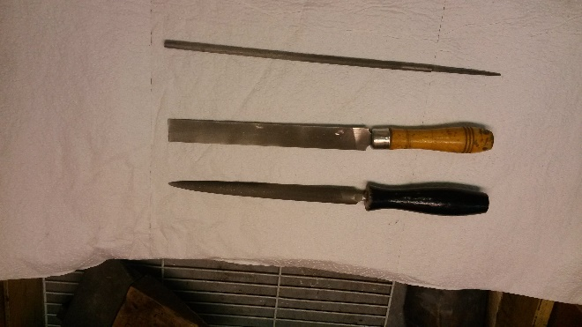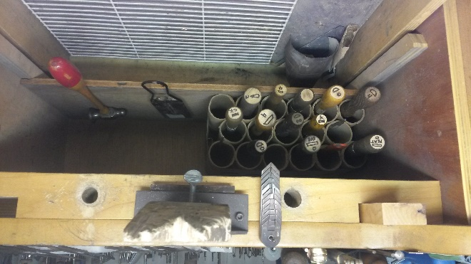

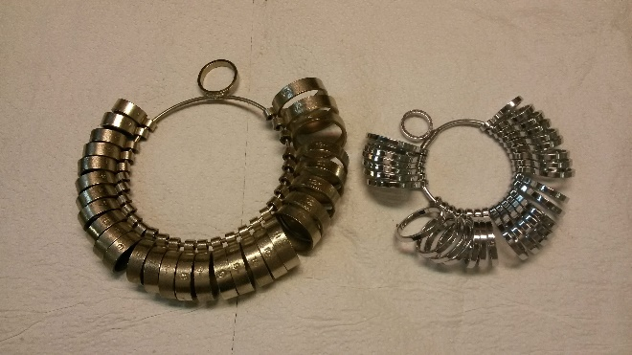
Finger gauge set
If you make rings then at some point you will need a set of “ring sizers”. Do not get the cheap plastic ones as they are always the wrong size. These are needed only if you will be making rings.

Fordom shaft or dremal tool
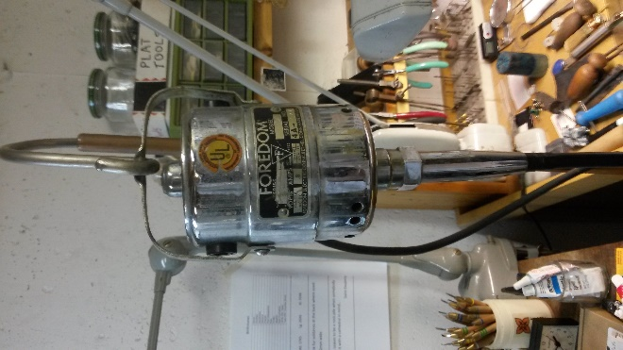
One thing you will want to get is some sort of rotary tool. The default rotary tool that most jewelers use is a ‘Fordom’ Flex Shaft with a #30 handpiece. The nice thing about the Fordom flex shaft is that you do not have to hold a heavy, hot motor as you work. You can also purchase a variety of hand pieces that do different things and fit the job you are doing.
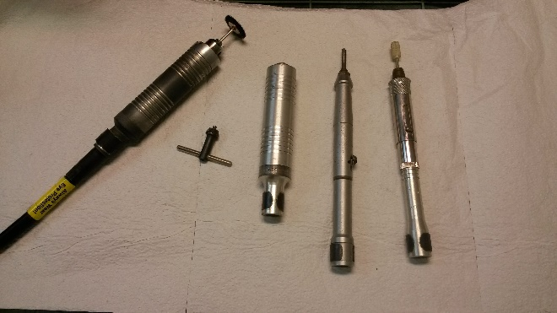
The two hand pieces on the left are #30’s, the next is a ‘hammer’ hand piece and the one on the left is a slim-line hand piece that uses collets instead of a Jacobs chuck.

Hammers
You will over time amass quite a collection of hammers! The thing to remember is that whatever marks are on the face of the hammer will be transferred to your work so only hit jewelry metals with polished hammers.
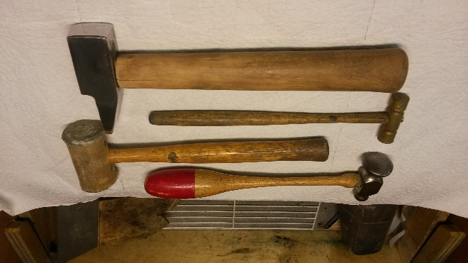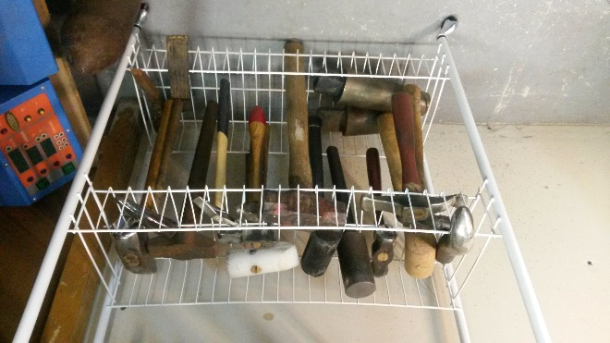
You will want to make a rack at some point to store your hammers. It does not have to be fancy but it will make it easier to find the one you want.
Some of the different types of hammers are listed below.
- Riveting--used for forming metal and for riveting.
- Embossing--also known as repoussé, embossing works the metal from the back to form three-dimensional shapes.
- Forming--used to move heavy-gauge metal quickly. Also known as a “BFH”.
- Raising--for creating a seamless form without thinning the metal. With two rectangular faces.
- Planishing--used for smoothing the surface of gold, silver, brass, and other metals.
- Chasing--a multi-purpose hammer for chasing, chiseling, riveting or peening.
- Mallet—A hammer with a soft face. Useful for forming, bending and shaping without scratching or marring surfaces. Made from brass, rawhide, nylon, paper or plastic or other materials.

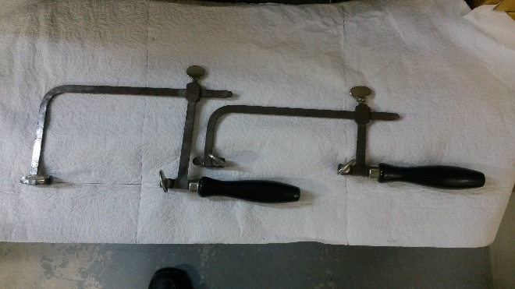
Jeweler’s saw frame and blades
The one tool you will use almost as much as your files will be the jewelers saw. You will want to have at least one with a variety of blades. The blades come in sets of a dozen each. You will break blades so make sure you get plenty.

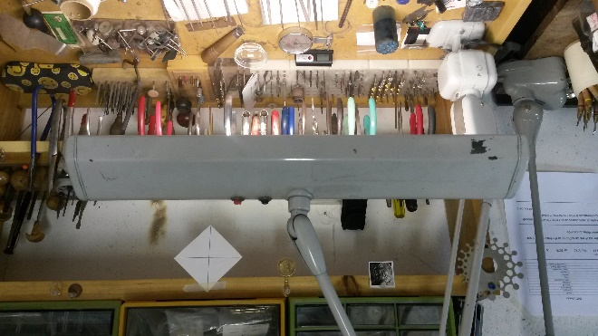
Lighting
Good light is essential to good workmanship. You should have bright light that does not throw shadows. A 2 tube florescent lamp on a swing arm will help you see what you are doing.

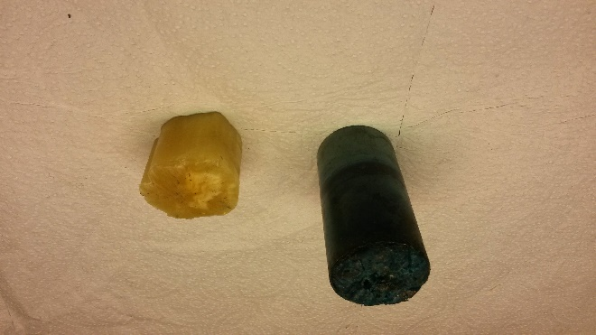
Lubricant
When you are using any rotary tool for cutting and grinding metal, you will need to use a lubricant of some type. It make the tool cut easier as well as keeps the temperature lower. When cutting it helps you cut a better line and you will break fewer saw blades. Some common lubricants include commercial jeweler’s lubricants, Bees wax, and wintergreen oil among others.

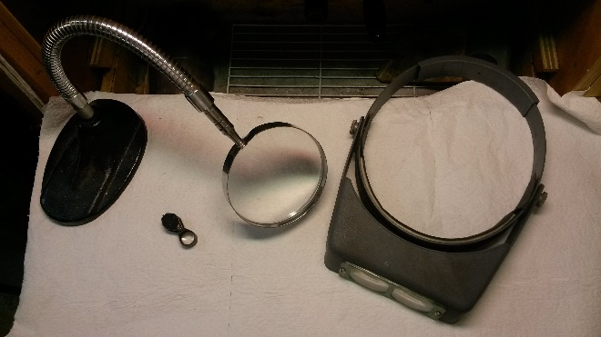
Magnifiers
You will need at the minimum a 10X triplet loupe to examine jewelry as you are working on it. A small magnifying glass on a gooseneck works well for general work and some sort of magnifying visor will come in handy.

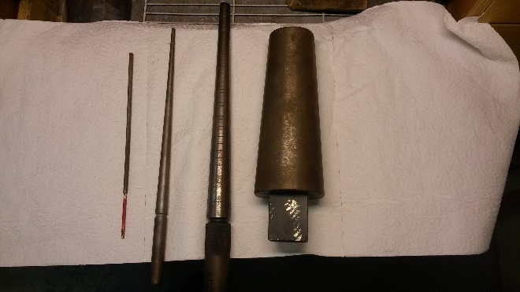
Mandrels
“Mandrel” is a fancy term for a long wood, plastic or metal form that you can shape metal over. Most are tapered and there are as many sizes and styles as you can imagine. From left to right in is a small straight mandrel for winding jump-rings, a tapered bezel mandrel, a graduated ring mandrel and a bracelet mandrel.

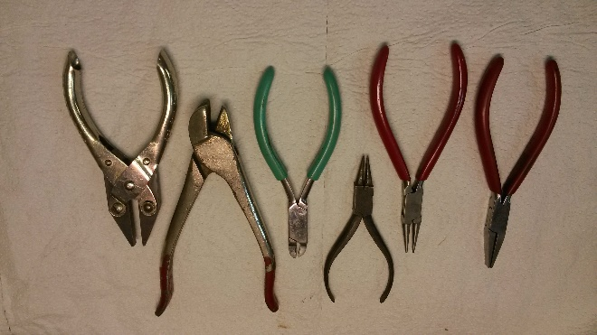
Pliers
One of the many tools you will use every day is your set of pliers. To start you should get a set of the following pliers.
- Round nose pliers
- Needle nose pliers
- Flat pliers
- Chain nose pliers
From left to right they are: ½ round, round nose, short round nose, goose-beak pliers for setting gems, ring bending, and parallel close. As you collect tools you will collect a wide variety of pliers. Many times you will have a need for a special pliers and you will be able to modify a pair for the task.

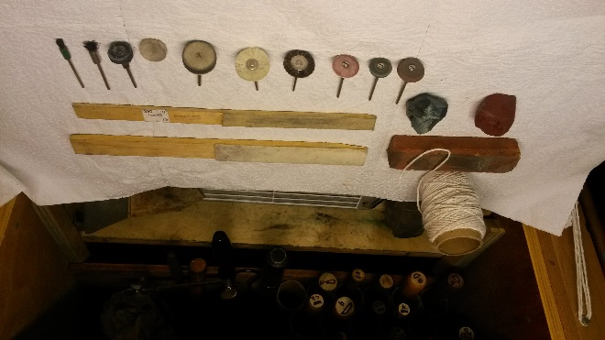
Polish and polishing tools
You will, in time, learn a lot about polish and how to use them. To start with I would suggest getting the following three polishes that you see in the picture. Tripoli (The rust colored bar at the left). Red Rouge (The red polish at the left). Zam (The lighter colored polish on the right). The Tripoli is used for your first polish and will remove file and sanding marks. The rouge is for adding a high shine to your work. Zam is used on silver and will works well for moderate material removal and gives a nice polish. You will also use buffing sticks with a bit of felt or chamois glued to them. Use them the same as you would a sanding stick. For your rotary tool the bottom row has from left to right: three rubberized abrasive wheels (course, medium and fine). Bristle brushes, (medium bristle, and fine bristle). Three cotton buffs, and two ‘end’ bristle brushes.

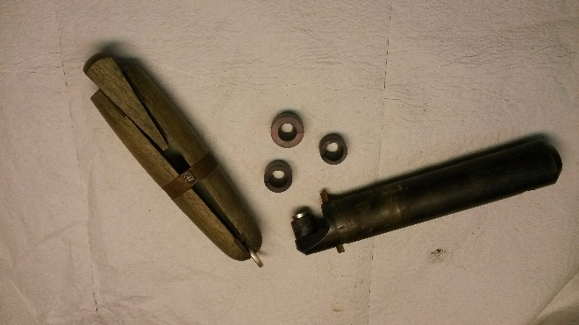
Ring clamp
A wood ring clamp will come in handy for not just rings. It will hold many things and it will keep your fingers from getting injured, burnt, and just plain sore! In the picture you can see the wood ring clamp on the right and on the left you can see an “inside ring clamp” that is used to hold a ring from the inside so you can work on the outside for gem setting or engraving.

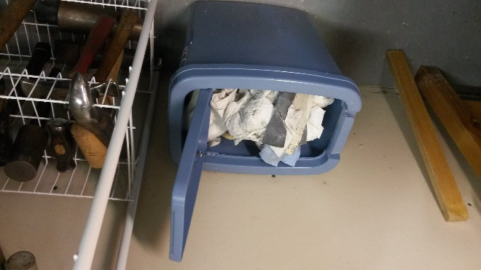
Recycling
The best argument for recyling is a question. Do you like money? Yeah, it comes down to that. Get a basket with a top that closes for all of your paper towels, polishing dust and other scraps. When you leave your shop wash your hands and blow your nose. You will be surprized at how much dust is on you. Have a small jar to keep all of your metal dust, filings and scrap in. A small jar that weighs a pound can translate into quite a bit of money when sent to a metals recycling center. Many will send you a check or they may pay out in metal stock.

Safety goggles
No picture is needed. When working in your shop have some sort of safety goggles on. Either have glasses that double or have goggles that fit over your glasses.

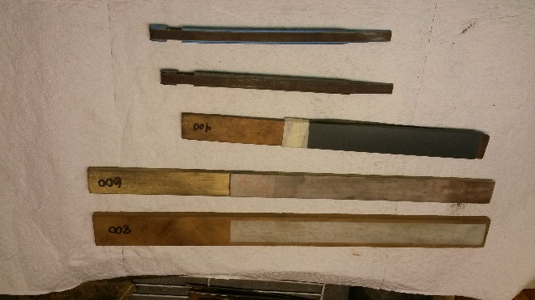
Sanding sticks
Sanding sticks are used all of the time. Many are just thin strips of wood with a piece of sand paper taped to them. As the paper is worn out, just rip that part off to expose freash paper. On the bottom of the photo you can see a couple of sanding sticks that work with rings of sandpaper.

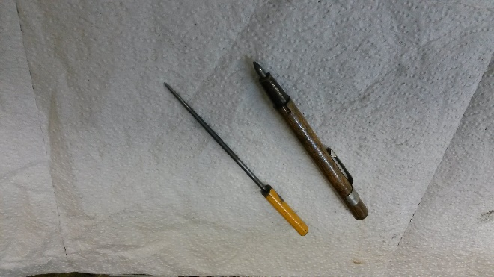
Steel scribe
You will only have a couple of these but you will use them all of the time. These are used to mark metal all of the time. The one on the left is a commercial scribe and the one on the right is made from an old file that has been inserted into a piece of broken pencil and apoxyied.

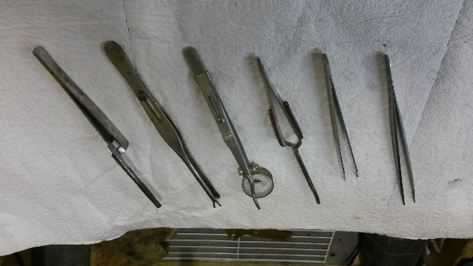
Tweezers
Tweezers are like pliers. You will end up with many more then you really need and many will be modified to do a single special job. From the left to the right: Large gem tweezers, fine tip tweezers, reverse grip soldering tweezers, LaVaque Head & Shank Tweezers, locking tweezers that have been modified for gluing pearls to earrings, reverse locking tweezers.
As a side note, I worked with Barry LaVaque at a shop in Madison Wisconsin when he was just inventing his head & shank tweezers and was starting the patent process. I saw them and knew he would be successful selling them some day.

